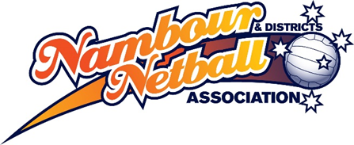

Junior Club Carnival 8-16yrs Nomination Form

WHEN: Sunday 18th October 2020
WHERE: Nambour & Districts Netball Association Courts
Victory Park, Laidlaw Rd, Woombye
AGES: 8 - 12yrs competitive & non-competitive divisions
12 - 16yrs competitive divisions only

CLUB & SCHOOL TEAMS WELCOME

GAMES TIMES: 8.00am – 3.00pm (times TBC)
ENTRY FEE: $100.00 per team.

- This is a Club Carnival NO REPRESENTATIVE TEAMS permitted.
- The Committee reserves the right to re-grade teams.
- Each team is to provide a CAPABLE UMPIRE to umpire own games.
- Divisional winners and runners-up will be presented with medals/awards up to 9 players.
- $20.00 FINE WILL APPLY FOR EVERY UMPIRING DUTY NOT FULFILLED BY A TEAM.

NOMINATIONS CLOSE: 9th OCTOBER 2020

Club/School Name: ________________________________________________________
Contact name: _____________________________ Phone number: _________________
Contact email address: _____________________________________________________
No. of teams nominated: _____________ @ $100.00 per team = Total $ ______________
Direct Debit: Nambour and Districts Netball Association, Heritage Bank
BSB: 638 070 A/C: 4191706 Reference: Club & Team name
Email nominations to: carnival@nambournetball.com.au

Team Name | Age | - Non  Competitive | Competitive | - Competitive Strength (tick one)  Weak Medium Strong
 | 8-10
 | 10-12
 | 12-13
 | 13-14
 | 15-16

www.nambour.qld.netball.com.au

